RACE/DRAC (Introduction)
Resource Assistance & College with Excellence (RACE) Centre is an innovative and ambitious scheme launched by commissonerate of college education, Rajasthan (Jaipur). Under this scheme there are 33 RACE centers are in total selecting one district headquarters' biggest college as a district nodal college of RACE centre. All the 252 Govt. Colleges of Rajasthan are being benefited through this scheme since the nodal colleges assist the other colleges of the district with academic, financial, sports and infrastructural resources and facilities. Under the scheme of RACE in each district of Rajasthan a District Resources Assistance Committee (DRAC) is constituted comprising the principals of all govt. colleges of the district as the members and the principal of nodal college (RACE centre) as the Chairman of it. Thus, RACE is a very helpful scheme in higher education to assists the govt. colleges with academic and infrastructural facilities.
Meetings:
- An essential meeting of RACE/DRAC was held on 09th Aug., 2019 at Seminar Hall in Lohia College under the chairman of Principal, Prof. Dilip Singh Punia. All the Principals of Govt. Colleges of Churu District participated in this meeting along with the incharge of RACE of their colleges respectively. Dr. Saumitra Nath Jhan and Sh. G. K. Soni participated in the meeting as the representative of Commisonerate College Education, Jaipur. All the present members discussed on the various academic, sports, financial and infrastructural problems of the govt. colleges of the district, Churu. It was unanimously decided to provide faculty members for 06/04 days in a month where there is a situation of Zero post, and to assist the needy colleges by providing all possible resources and facilities from the Nodal College, Govt. Lohia College, Churu and as well as from the other govt. colleges of the district where resources are available in sufficient amount.
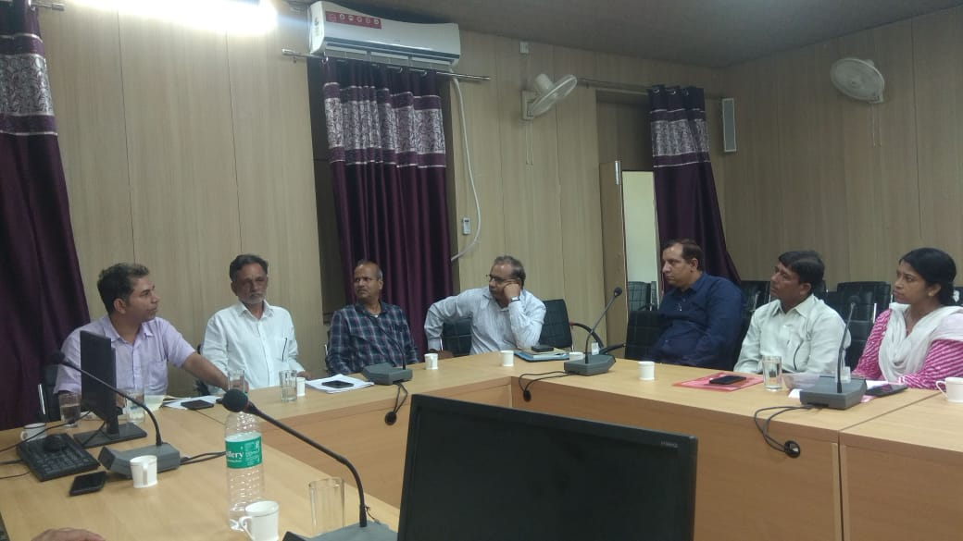
Meeting held on 09/08-2019
- An important workshop of Annual Audit Programme (AAP) as per the instructions of Commisonerate College Education, Jaipur was organized under the Scheme of Resource Assistance & College with Excellence (RACE) on 18 Sept., 2019 at Seminar Hall of the College to train the principals and RACE Incharge of all the Govt. Colleges Churu District. This training workshop was held to give the proper training to the participants of the Govt. Colleges for the preparation of Annual Audit Programme (AAP) of their colleges. The workshop was inaugurated by Prof. Dilip Singh Punia, Principal of Nodal College (RACE Centre) and the training to the participants was given by the senior faculty members of college, Sh. Mahaveer Singh, Dr. A. L. Kulhari, Dr. Prashant Kumar Sharma and Dr. Sumer Singh.

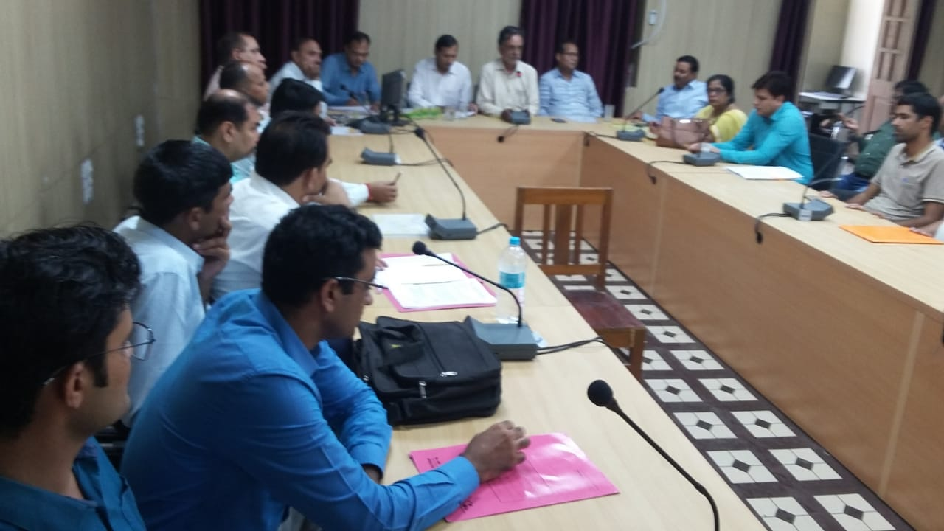
Meeting held on 18/09-2019

